Recursion

Recursion is the process of defining something in terms of itself.

A physical world example would be to place two parallel mirrors facing each other. Any object in between them would be reflected recursively.

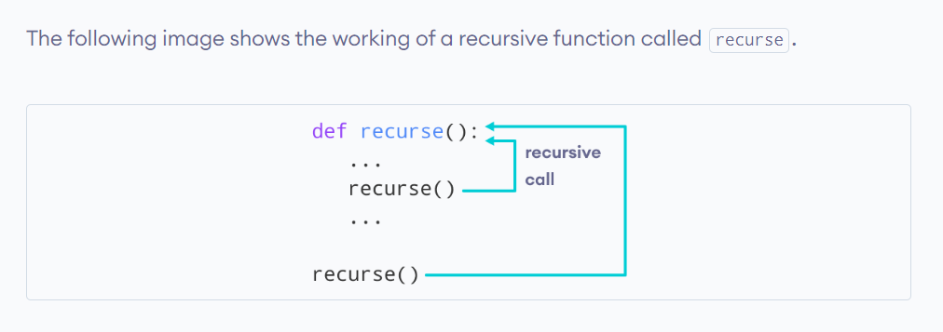

Example:-

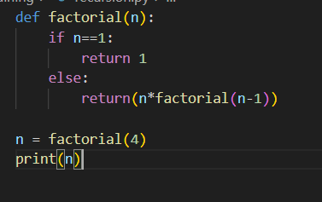

Output:-

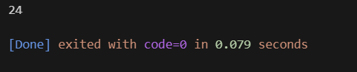

## Advantages of Recursion

1. Recursive functions make the code look clean and elegant.
2. A complex task can be broken down into simpler sub-problems using recursion.
3. Sequence generation is easier with recursion than using some nested iteration.

## Disadvantages of Recursion

1. Sometimes the logic behind recursion is hard to follow through.
2. Recursive calls are expensive (inefficient) as they take up a lot of memory and time.
3. Recursive functions are hard to debug.